
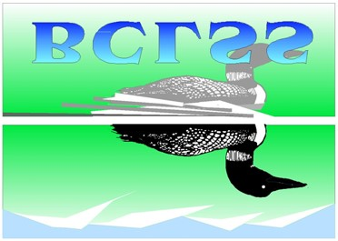
BC Lake Stewardship and Monitoring Program Twin (Nipit) Lake 1999 - 2003

A partnership between the BC Lake Stewardship Society and the Ministry of Water, Land, and Air Protection

The Importance of Twin Lake & its Watershed

British Columbians want lakes to provide good water quality, aesthetics, and recreational opportunities. When these features are not apparent in local lakes, people begin to wonder why. Concerns often include whether the water quality is getting worse, if the lake has been polluted by land development or other human activities, and what conditions will result from more development within the watershed.

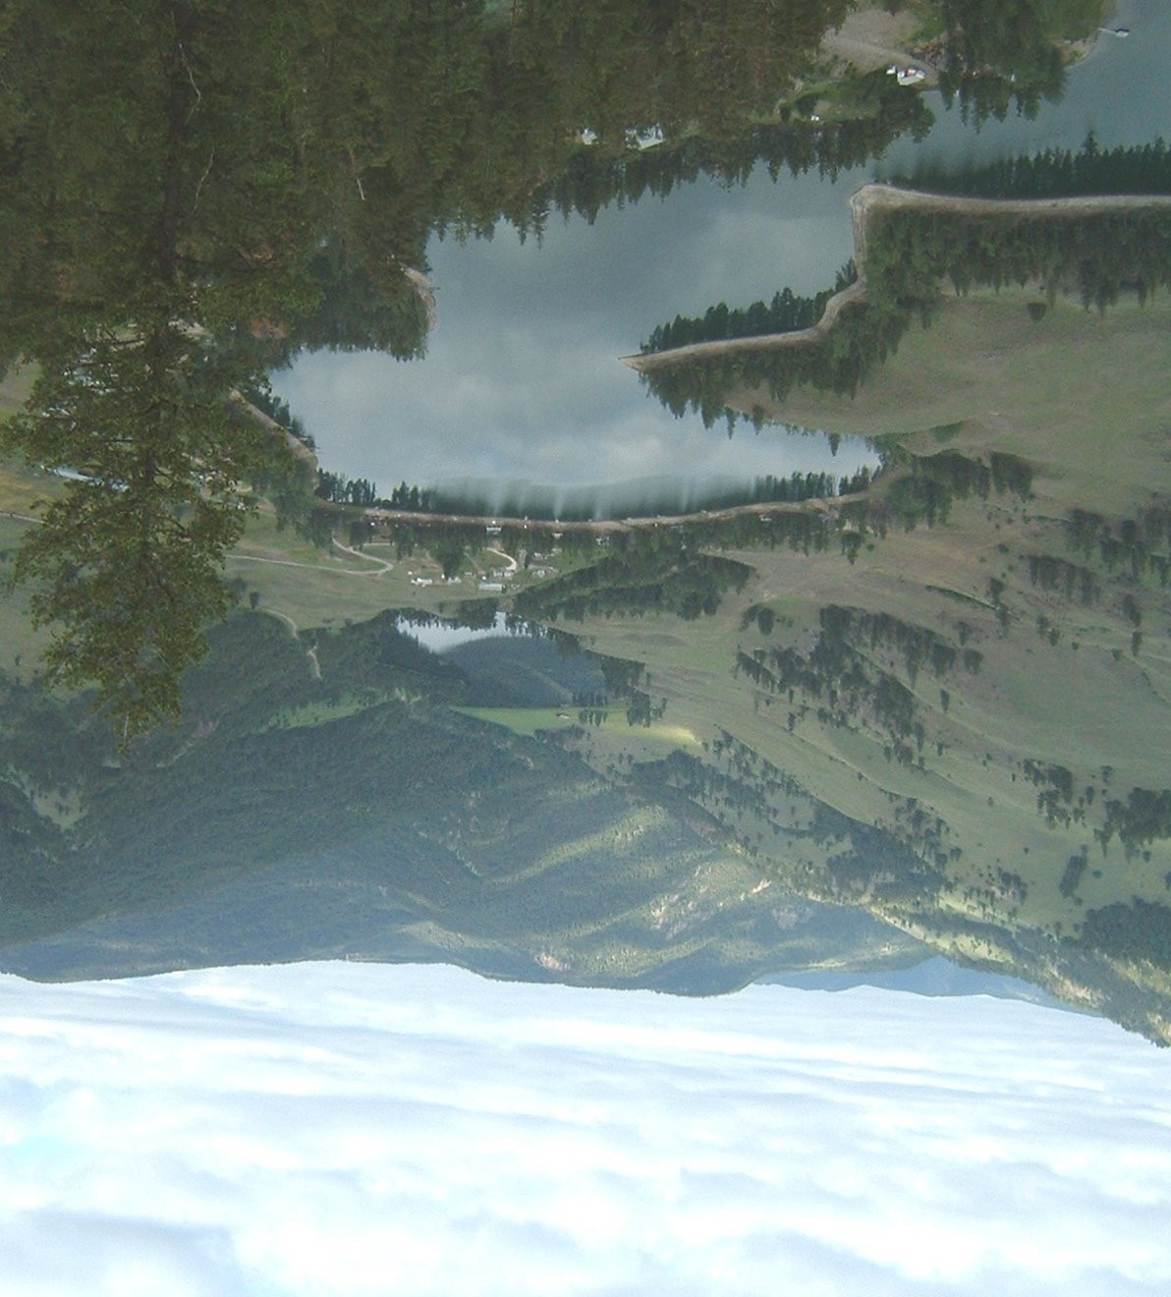
The BC Lake Stewardship Society (BCLSS), in collaboration with the Ministry of Water, Land, and Air Protection (MWLAP), has designed a program, The BC Lake Stewardship and Monitoring Program, to address these concerns. Through regular water sample collections, we can come to understand a lake's current water quality, identify the preferred uses for a given lake, and monitor water quality changes resulting from land development within the lake's watershed.

The BCLSS can provide communities with both lake-specific monitoring results and educational materials on general lake protection issues. This useful information can help communities play a more active role in the protection of the lake resource. Finally, this program allows government to use its limited resources efficiently thanks to the help of local volunteers and BCLSS.

For years, Twin Lake has been of interest for many water quantity reasons such as an abundance of water causing flooding in wet year cycles and inadequate infilling in dry years. In 1997, concerned residents of Twin Lake contacted the BCLSS, the Regional District of OkanaganSimilkameen (RDOS), and the Ministry of Water, Land, and Air Protection with their concerns for the health of the lake. Soon after these initial meetings, the Twin Lake Stewardship Group was established. The group began monitoring in 1999, and, along with the help of MWLAP, has successfully collected four years of data, including biweekly Secchi disk readings (for clarity) and annual lake water analysis such as dissolved oxygen, temperature, nutrients, and bacteriology (such as coliforms). The group has also completed a depth profile (bathymetric chart) for Twin Lake. Prior to this data collection, there were few water quality records kept by the Ministry of Water, Land, and Air Protection for Twin Lake.

A watershed is defined as the entire area of land that moves the water it receives into a common waterbody. The true definition represents a much larger area than most people usually consider. Watersheds are where much of the ongoing hydrologic cycle takes place and play a crucial role in the purification of water. Although no new water is ever made, it is continuously filtered and recycled as it moves through watersheds and other hydrologic compartments. The quality of the water resource is largely determined by a watershed’s capacity to buffer impacts and absorb pollution.

Every component of a watershed has an important function in maintaining good water quality and a healthy aquatic environment. It is a common misconception that detrimental land use practices will not impact water quality if they are not in the area immediately surrounding a water body. Poor land-use prac-
tices anywhere in a watershed can eventually impact the water quality of the downstream environment.

Human activities that impact water bodies range from small and numerous non-point sources to large point sources of concentrated pollution (e.g. outfalls, spills, etc.). Undisturbed watersheds have the ability to purify water and repair small amounts of damage from pollution and alteration. However, modifications to the landscape and increased levels of pollution impair this ability.

Twin Lake is located in the Okanagan-Similkameen in Southern British Columbia, approximately 20 kilometres southwest of Penticton (off Highway 3a). The Twin Lake area consists of two small lakes joined by a stream, along which is an earth-filled dam installed to increase water storage in the upper lake. The upper, or south, lake is approximately 32.4 ha (80 acres), and is known by locals as Horn Lake. While the lower, or north, lake is approximately 36.45 ha (90 acres) and is variously called lower Nipit, lower Twin, or Twin Lake. They are situated 792.5m above sea level (2,600 feet).

The upper lake (Horn Lake) is fed by Horn Creek, from the northward sloping portion of the upper watershed. The lower lake, or Twin Lake, is slightly larger than Horn Lake and is fed by its discharge. The total area of this watershed is approximately 19km². There is no natural surface outlet for Twin Lake, making the watershed sensitive to any changes such as increases in nutrients or pollution. With no flushing action, anything added into the lake will remain there for an extended period of time. Historically, Twin Lake originated from large outwash kettles resulting from pre-ice drainage basins. Because of the high groundwater absorption of the upper watershed, there are significant fluctuations in surface water levels of Twin Lake during wet and dry weather cycles.

Due to the rainshadow effect of the Cascade Mountain Range, the watershed surrounding Twin Lake is relatively arid. As the wind rises over the mountains, the air cools and the moisture condenses. As it passes over and down the lee side of the mountain, it warms and the clouds dissipate. This results in less rain and, therefore, creates a relatively arid environment in the Twin Lake watershed.

Historically, the land around Twin Lake supported a dude ranch and beef cattle. The Twin Lake Dude Ranch offered guests a combination of activities including horseback riding, hiking, as well as swimming and boating in the “crystal clear, freshwater lakes.” During the 1960s, the recreational use of the land and water increased. People began to appreciate and utilize the area for its fishing, camping, hiking, boating, and ice fishing potentials. In the past, Twin Lake has been stocked with a variety of fish species. In the past five years, both Brook Trout fingerlings and Rainbow Trout yearlings have been added to the lake.

The water level of Twin Lake has been affected by various human means since 1942 when dredging occurred on the stream between the two lakes. Water level control first occurred in the late 1940s when, during wet years, water was pumped out to Park Rill. The Lower Nipit Improvement District was formed in 1965 and has maintained control of the water levels since that time. More recently, the level of Twin Lake has been controlled by a pumping station. The pump was installed as a result of high spring run-off and potential serious flooding of residential sewage collection systems. Although pumping is not necessary every year (last recorded pumping was in the spring of 1998), the Lower Nipit Improvement District continues to monitor the water levels and pump accordingly.

Twin Lake Watershed Map
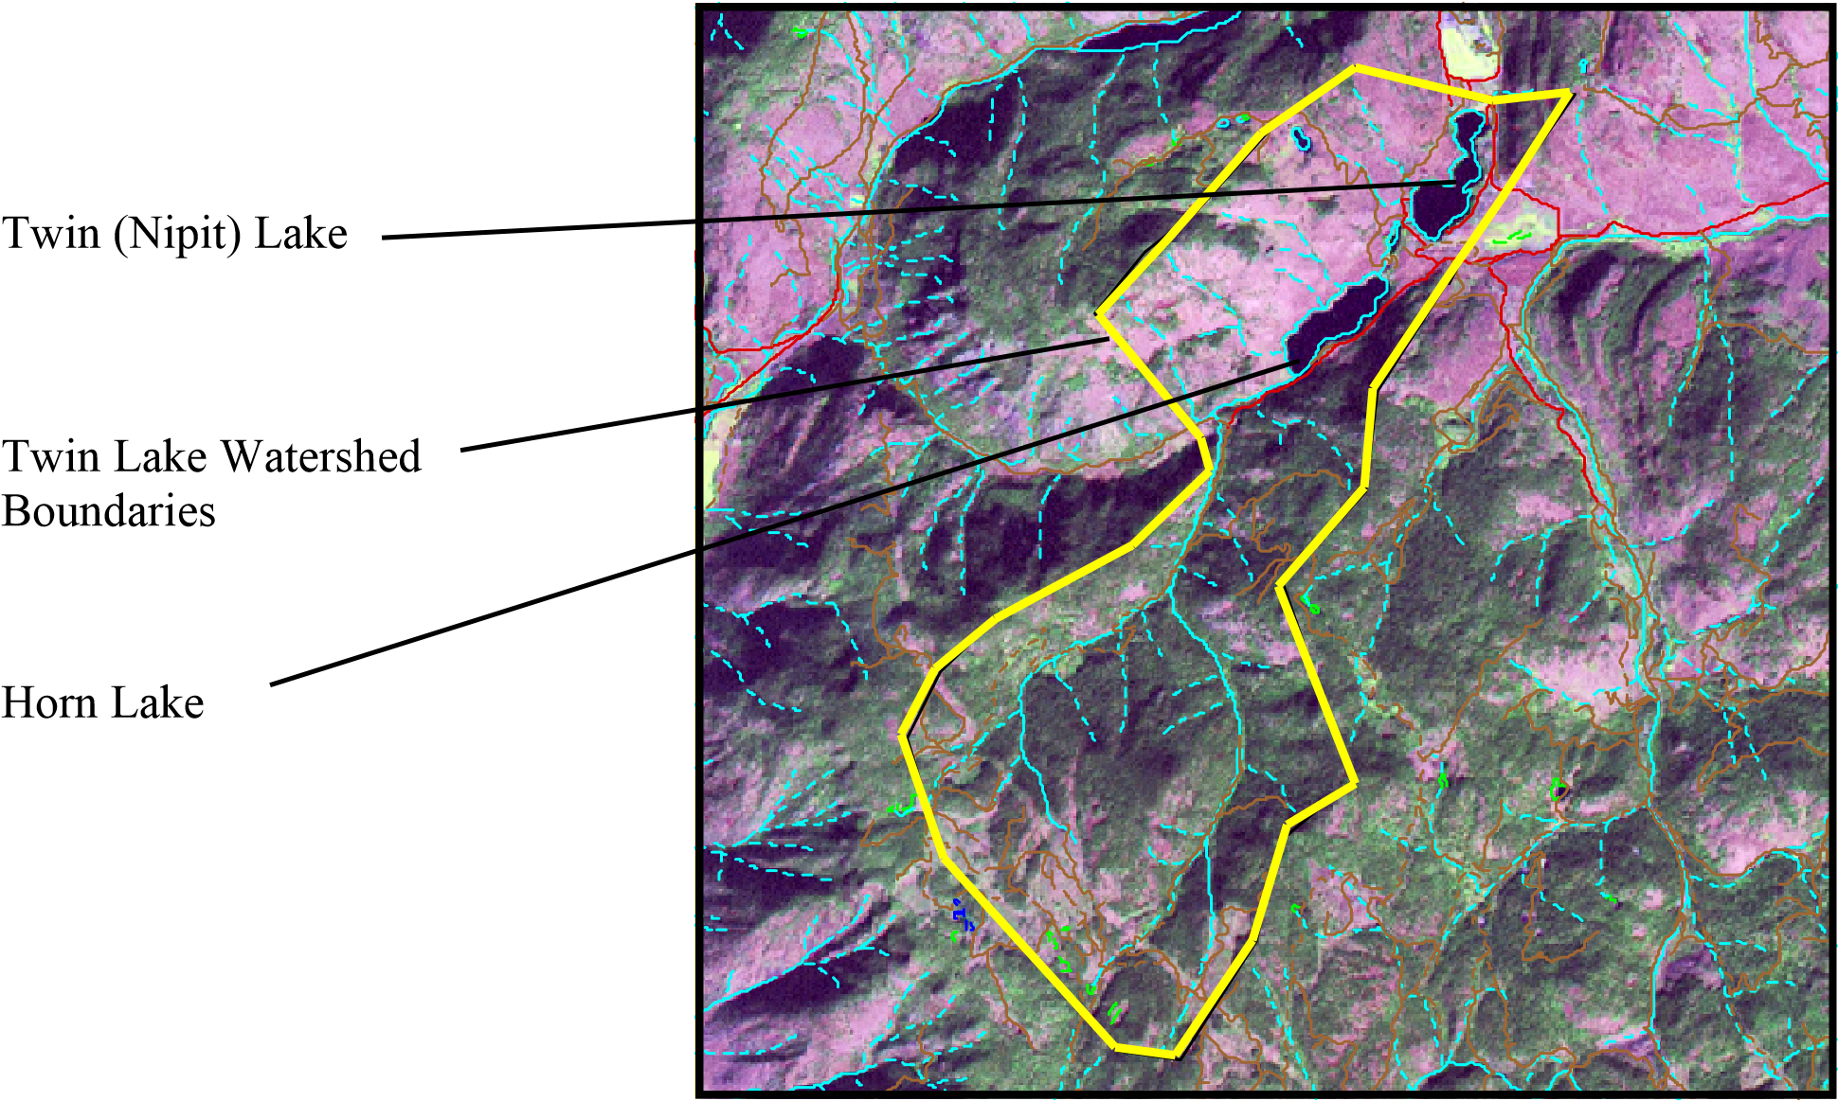

Non-Point Source Pollution and Twin Lake

Twin Lake is very sensitive to pollution and nutrient loading due to the fact that there is no outlet and, consequently, no flushing action. In other words, what enters the lake, stays in the lake. Therefore, any addition of pollution or excess nutrients can have a lasting effect on the lake.

One type of pollution, point source pollution, originates from municipal or industrial effluent outfalls. None of these occur in the Twin Lake watershed. Other pollution sources exist over broader areas and may be hard to isolate as distinct effluents. These are referred to as non-point sources (NPS) of pollution. Shoreline modification, road stormwater runoff, onsite septic systems, agriculture, and forestry are common contributors to NPS pollution. One of the most detrimental effects of NPS pollution is nutrient loading to water bodies.

Phosphorus and nitrogen are the two nutrients of interest to freshwaters. The amount of phosphorous in a lake can be greatly influenced by human activities. As erosion or septic tank seepage increases in the watershed, phosphorous enters surface waters. As nutrients increase in a lake, algal production increases, decreasing water clarity. Algae sink to the bottom and decay, consuming oxygen and releasing nutrients. In many lakes these nutrients become trapped in bottom sediments. However, when decay consumes more oxygen than is dissolved in the water, the bottom waters become anoxic (devoid of oxygen). Anoxic bottom sediments release phosphorous to the overlying waters. When excessive amounts of phosphorous and other nutrients are released, nuisance algal blooms may cause water taste and odour concerns, reduced water clarity, dissolved oxygen depletion, and fish kills.

Onsite Septic Systems and Grey Water
Onsite septic systems effectively treat human waste water and wash water (grey water) as long as they are properly located, designed, installed, and maintained. When these systems fail they become significant sources of nutrients and pathogens. In a lake system without surface outflow, such as Twin Lake, high nutrient loading from sources such as septic tanks can result in detrimental and long-lasting consequences.

Stormwater Runoff
Lawn and garden fertilizer, sediment eroded from modified shorelines or infill projects, oil and fuel leaks from vehicles and boats, road salt, and litter can all be washed by rain and snowmelt from properties and streets into watercourses. Phosphorus and sediment are of greatest concern as they provide excess nutrients and/or a rooting medium for weedy aquatic plants and algae. Pavement prevents water infiltration to soils, collects hydrocarbon contaminants during dry weather, and increases direct runoff of these contaminants to lakes during storm events.

Agriculture
Agriculture includes grains, livestock, and mixed farming. These practices can alter water flow and increase sediment and chemical/bacterial/parasite inputs to water bodies. Problems such as increased fecal coliform counts and loss of riparian vegetation can be a result of intense cattle activity in areas adjacent to water. A bacteriological test conducted in 2002 on Twin Lake indicated that fecal coliform counts were high. Improvement projects such as fencing may be an important step in ensuring the safety of the lake water.

Boating
Oil and fuel leaks are the main concerns of boat operation on small lakes. With larger boats, sewage and grey water discharges are issues. Due to these serious effects, and the slow flushing rate of Twin Lake, there is currently a “No Motors” rule on the lake. This rule protects the lake from gas, oil, and other contaminants that may harm this sensitive ecosystem. Other problems associated with boating (motorized or not) include litter, the spread of aquatic plants, shoreline erosion, and the churning up of bottom sediments and nutrients.

Twin Lake Bathymetric Map
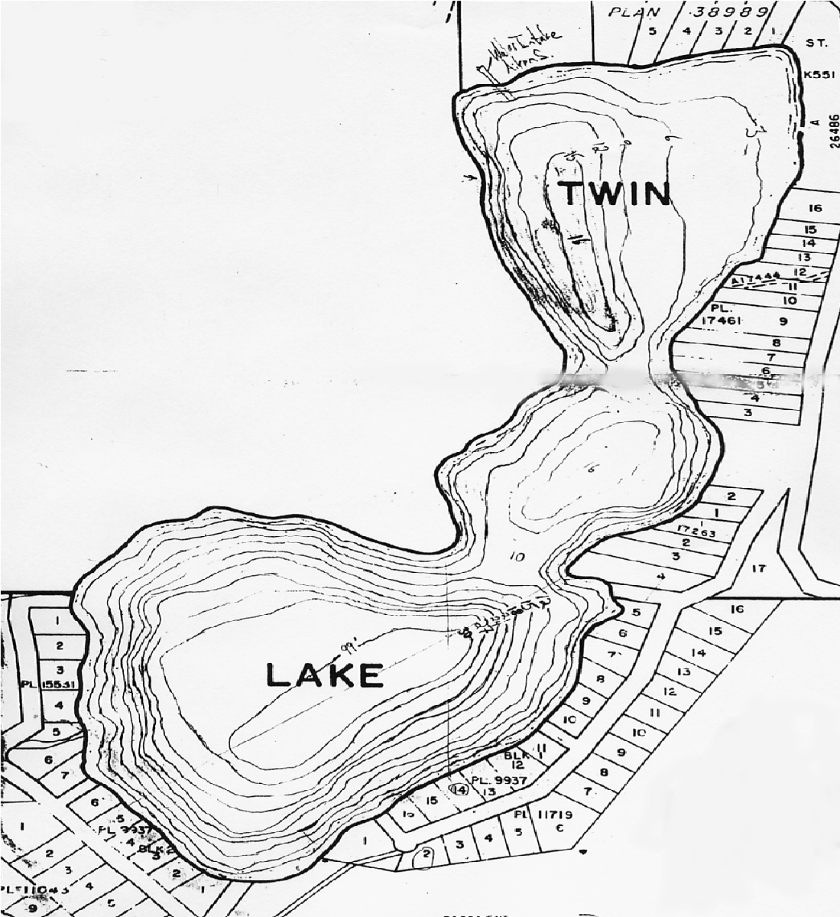

3
6

9

12
15

16

16
12

10

27

30

24

21
15

18

Contours in 3 meter increments of depth
(
August 2002)

What’s Going on Inside Twin Lake?

Temperature
Most lakes in BC, including Twin Lake, form layers (stratify), with the coldest water layer (hypolimnion) near the bottom for much of the ice-free period of the year. Because colder water is more dense, it resists mixing into the warmer, upper layer (epilimnion) for much of the summer. The area of rapidly decreasing temperature with depth, between the warm upper and cold lower layers of water, is called the thermocline. This layer marks the transition between the top and bottom layers and can prevent mixing between the two. The thermocline is usually most pronounced in the summer.

In the early spring and late fall, stratified lakes tend to mix (overturn) as wind energy overcomes the reduced temperature and density differences between surface and bottom waters. In the winter, lakes re-stratify under ice with the most dense water (4°C) near the bottom. Because these types of lakes turn over twice per year, they are called dimictic lakes. This is the most common type of lake in British Columbia. Some lakes also stratify due to water density from increased salinity in bottom waters. These lakes are called meromictic, meaning partial mixing; Twin Lake appears to follow this pattern .

Temperature stratification patterns are very important to lake water quality. They help determine many of the changes in dissolved oxygen, nutrients, and algal conditions. Because Twin Lake is relatively sheltered, winds may not be able to significantly mix surface waters down to the bottom. This may cause incomplete fall and spring overturn or mixing events. Stratification typically occurs soon after ice-off and lasts until shortly before surface waters freeze again in the late fall. During this period the thermocline is well defined between approximately the 4 and 10 metre depths. The epilimnion layer in Twin Lake is relatively shallow (0-4m), while the hypolimnion layer is relatively deep (10-32m). A curious aspect of the vertical temperature profile is a slight, but frequent increase in temperature in the hypolimnion (between 20m and 30m). This is coincident with significant increases in hard- ness, conductivity, chloride, silica, and decreases in sulphate. These increases are additional indications of incomplete vertical mixing of the lake and meromictic conditions.
Temperature (ºC)
Temperature for Twin Lake
(September and January)
0
5
10
15
20
25
30
35
0 1 2 3 4 5 6 7 8 9 10 11 12 13 14 15 16 17 18 19 20
Depth (m)
January
September

Dissolved Oxygen
Oxygen is essential to life in lakes. It enters lake water from the air by wind action and plant photosynthesis. Oxygen is consumed by respiration of animals and plants, including the decomposition of dead organisms by bacteria. A great deal can be learned about the health of a lake by studying dissolved oxygen patterns and levels.

Lakes that are unproductive (oligotrophic) will have sufficient oxygen to support life at all depths throughout the year. As lakes become more productive (eutrophic), and increasing quantities of plants and animals respire and decay, more oxygen consumption occurs, especially near the bottom where organic matter accumulates.
Dissolved Oxygen in Twin Lake (September and January)
0
5
10
15
20
25
30
35
4
5
6
7
8
9
2
10
0
1
Depth (m)
January
September
Dissolved Oxygen (mg/L)
3
Oxygen concentration and cycling are mainly dependant on lake thermal stratification patterns and, like temperature, are seasonally variable. Generally, in lakes that fully mix, oxygen is distributed throughout the lake during overturn (spring and fall). In the summer, when the lake becomes thermally stratified, oxygen concentration in the hypolimnion of productive lakes becomes depleted.

In Twin Lake there are two barriers to oxygen reaching the bottom of the lake. During much of the ice-free season there is a thermal gradient or thermocline between 5 and 10 metres which prevents waters above and below this layer from mixing due to differences in density. Further down in the water column, at about 20 metres, the water again changes, increasing in salinity (and slightly in temperature) to, at times, almost double that of the surface waters. Salinity levels, if proven to be consistently high year round in the bottom waters of the lake, would present another barrier to the complete vertical mixing of Twin Lake.

Hydrogen sulphide gas, a by-product of anaerobic decomposition of organic matter, has been encountered below the 20 metre depth on all sampling dates. When the thermocline is eroded in the fall, this gas may mix further up in the water column and be detected in water intakes. Analysis of a sediment core collected from Twin Lake by the Okanagan University College Freshwater Science program indicates that sediments in deeper portions of the lake do not appear to have been exposed to oxygenated waters. This may be another indication of a meromictic condition.

Trophic Status
The term “trophic status” is used to describe a lake’s level of productivity and depends on the amount of nutrients available for plant growth, including algae.

As stated earlier, lakes of low productivity are referred to as oligotrophic, meaning they are typically clear lakes with low nutrient levels, sparse plant life, and low fish production. Lakes of high productivity are eutrophic. They have abundant plant life, poor water quality and, at times, high fish production, provided that dissolved oxygen depletion is not severe. Lakes with an intermediate productivity are called mesotrophic and have moderate nutrient levels and fish production. Establishing the trophic condition of a lake allows inter-lake comparisons and general biological and chemical attributes of a lake to be estimated. The trophic status of the water is often determined from levels of phosphorous, algal chlorophyll A (the green photosynthetic pigment), and water clarity.

Water Clarity
Water clarity is measured using a Secchi disk. The Secchi disk is an 8-inch disk with four quadrants – two black and two white. The disk is lowered into the water until one can no longer see the difference between the black and white quadrants. This depth between the disk and the surface of the water is the Secchi depth and can be compared to readings taken to determine seasonal and inter-year changes in water clarity. As the figure below shows, Twin Lake is generally clearest during mid summer (4-6m), following the algal growth period (2-4m) in the spring, and prior to the lesser algal growth peak (4-5m) in the fall. This is typical of fresh-
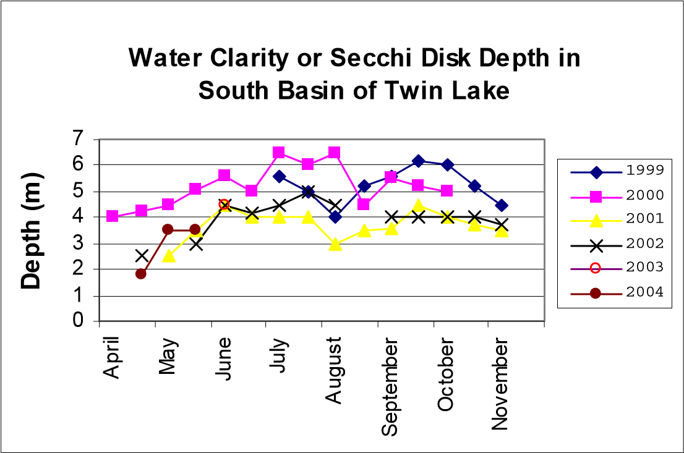
waters. Twin Lake is clearer in some years than others, likely as a result of water and nutrient inputs during years of higher run-off or may be related to mixing events when nutrient rich bottom waters are mixed into surface waters of the lake. Water clarity appears to have decreased over the study period, however more frequent observations over many years are needed before conclusions may be drawn. Local observations suggest that algal blooms are more common now than in the past.

Algal cells within the water column are the primary determinant of water clarity in Twin Lake. Chlorophyll A, which is a measure of algal or phytoplankton abundance, ranges from below detection to a maximum of 7 ug/L and averages approximately 3 ug/L over the growing season.

Phosphorus
An increase in phosphorus can result in an increase in algae and a decrease in water clarity. Algae provide food for zooplankton (tiny animals floating in the water column), which are in turn, food for other organisms, including fish. As previously mentioned, an overabundance of phosphorous and algae can cause problems within a lake such as reduced water clarity, fish kills, and taste and odour concerns for drinking water use.

Total Phosphorus (mg/L) for
Twin Lake
0.010
0.100
1.000
10.000
Jun-99
Dec-99
Jun-00
Dec-00
Jun-01
Dec-01
Jun-02
m
0.5
10
m
20
m
30
m
P-T (mg/L
)
Date
In most lakes, phosphorus is the nutrient in shortest supply and thus acts to limit the production of aquatic life. Total phosphorus levels in surface waters of Twin Lake appear to have increased slightly over the monitoring period as shown in the previous graph. Also notable are the consistently higher concentrations of phosphorus in deep waters of the lake, suggesting persistent periods of anoxia and nutrient release from sediments (internal loading) and decaying algae. This “internal loading” can be natural, but is often accelerated by phosphorus inputs such as septic tank leaks and agriculture influences.

As the table below indicates, by combining readings of total phosphorus, chlorophyll A, and Secchi disk depths, we can determine the productivity, or trophic status, of Twin Lake.
Trophic Status | Productivity | Total  Phosphorus Range | Chlorophyll A Range | Secchi Range
Oligotrophic | Low | 1-10 ug/L | 0-2 ug/L | > 5 m
Mesotrophic | Medium | 10-30 ug/L | 2-7 ug/L | 2-5 m
Eutrophic | High | > 30 ug/L | > 7 ug/L | < 2 m
Twin Lake | Medium - High | 22 ug/L | 3 ug/L | 4.5 m
The total phosphorus levels in the surface waters average 22 ug/L or parts per billion. Chlorophyll A measurements average 3 ug/L and the Secchi disk depth averages 4.5m. Based on these records, Twin Lake is mesotrophic. Increases in septic tank seepage, erosion from land disturbance due to residential development, agriculture, and forestry, can shift the trophic status of a lake such as this towards eutrophic or excessively productive conditions.

Bacteria
Because some lakeshore residents may use the lake for drinking water, bacteriological quality of the water is of interest. Bacteriological testing in 2002 indicated high fecal coliform counts that may be related to failing septic systems, waterfowl, or cattle activity along the lakeshore. Feces contamination, along with other problems such as the trampling of natural flora around the lake, occurs in areas of intense cattle activity. When natural flora is removed from the lakeshore the area loses its natural ability to filter nutrients and other contaminants (i.e. feces, bacteria). Further information regarding natural revegetation, naturalization of foreshores, and livestock fencing can be obtained from the BCLSS.

Salinity
Salinity is the concentration of salts dissolved in water. The salinity of a lake is influenced by the drainage basin, its soils, the runoff, and the evaporation and precipitation rates. Other influences include septic tank seepage and erosion from watershed disturbance.
With Twin Lake’s unique topography and lack of outlet, the system is very sensitive to watershed and climate changes. As freshwater inputs decrease, lake levels subside, and the nutrients and other material dissolved within the system begin to concentrate. Total dissolved solids, an estimate of salts dissolved in the waters of Twin Lake, have increased from approximately 48 ppm in 1969 to 280 ppm in 1999.

Significant increases in salinity can compromise the mixing processes within a lake. In a lake such as Twin Lake, this could have uncertain consequences. Lakes that do not fully mix (meromictic lakes) experience excessive build up of nutrients and salts dissolved in the hypolimnion. This can make the lake’s bottom waters toxic to fish and unsuitable for drinking.
Specific Conductance for Twin Lake
0
5
10
15
20
25
30
35
400
600
700
800
900
Depth (m)
Spring (May 2001)
Summer (August 2000)
Fall (November 2001)
Specific Conductance (uS/cm) 500

One approximation of salinity is specific conductance. As the graph above indicates, the specific conductance of Twin Lake increases drastically between 20m and 30m. The same trend appears during each season, indicating incomplete mixing (meromixis).

Future Plans for Twin Lake
The full scale monitoring of Twin Lake ended in 2003. spring (when the ice comes off) may be warranted to deterWeekly water clarity tests should continue indefinitely. Fur- mine the rate and effectiveness of overturn or vertical mixing ther studies that would document the success of mixing peri- in Twin Lake. A full scale monitoring plan may be considered ods in late fall (when surface water is near freezing) and in in a few years to determine how the lake has changed.

Tips to Keep Twin Lake Healthy

Yard Maintenance, Landscaping & Gardening

- Minimize the disturbance of shoreline areas by maintaining natural vegetation cover.
- Minimize high-maintenance grassed areas.
- Replant lakeside grassed areas with native vegetation.
- Do not import fine fill.
- Use paving stones instead of pavement.
- Stop or limit the use of fertilizers and pesticides.
- Do not use fertilizers in areas where the potential for water contamination is high, such as sandy soils, steep slopes, or compacted soils.
- Do not apply fertilizers or pesticides before or during rain due to the likelihood of runoff.
- Hand pull weeds rather than using herbicides.
- Use natural insecticides such as diatomaceous earth. Prune infested vegetation and use natural predators to keep pests in check. Pesticides can kill beneficial and desirable insects, such as lady bugs, as well as pests.
- Compost yard and kitchen waste and use it to boost your garden’s health as an alternative to chemical fertilizers.

Agriculture

- Locate confined animal facilities away from waterbodies. Divert incoming water and treat outgoing effluent from these facilities.
- Limit the use of fertilizers and pesticides.
- Construct adequate manure storage facilities.
- Do not spread manure during wet weather, on frozen ground, in low-lying areas prone to flooding, within 3 m of ditches, 5 m of streams, 30 m of wells, or on land where runoff is likely to occur.
- Install barrier fencing to prevent livestock from grazing on streambanks and lakeshore.

Onsite Sewage Systems

- Inspect your system yearly, and have the septic tank pumped every 2 to 5 years by a septic service company. Regular pumping is cheaper than having to rebuild a drain-field.
- Use phosphate-free soaps and detergents.
- Don’t put toxic chemicals (paints, varnishes, thinners, waste oils, photographic solutions, or pesticides) down the drain because they can kill the bacteria at work in your onsite sewage system and can contaminate waterbodies.
- Conserve water: run the washing machine and dishwasher only when full and use only low-flow showerheads and toilets.

Auto Maintenance

- Use a drop cloth if you fix problems yourself.
- Recycle used motor oil, antifreeze, and batteries. • Use phosphate-free biodegradable products to clean your car. Wash your car over gravel or grassy areas, but not over sewage systems.

Boating

- Do not throw trash overboard or use lakes or other waterbodies as toilets.
- Use biodegradable, phosphate-free cleaners in- stead of harmful chemicals.
- Conduct major maintenance chores on land.
- Use absorbent bilge pads to soak up minor leaks or spills.
- Check for and remove all aquatic plant fragments from boats and trailers before entering or leaving a lake.

- If livestock cross streams, provide gravelled or hardened access points.
- Provide alternate watering systems, such as troughs, dugouts, or nose pumps for livestock.
- Maintain or create a buffer zone of vegetation along a • streambank, river or lakeshore and avoid planting crops right up to the edge of a waterbody.

Eurasian milfoil, an aggressive invasive aquatic weed, has been sited in Twin Lakes. Be sure to familiarize yourself with this plant and remove and discard of any fragments.
Do not use metal drums in dock construction. They rust, sink and become unwanted debris. Use Styrofoam or washed plastic barrel floats. All floats should be labeled with the owner’s name, phone number and confirmation that barrels have been properly emptied and washed.
Who to Contact for More Information
Ministry of Water, Land and Air Protection The BC Lake Stewardship Society
Vic Jensen, RPBio.
Impact Assessment Biologist 102 Industrial Place
Penticton, BC V2A 7C8
Email: vic.jensen@gems3.gov.bc.ca

Twin Lake Stewardship Group:
Contact: Lloyd and Betty Purdy
Site 27a, Comp 5, RR1 Kaleden, BC V0H 1K0
Phone: (250) 497-8264

c/o Science Building 3333 College Way Kelowna, BC, V1V 1V7

or

#4-552 West Ave, Kelowna, BC,
V1Y 4Z4

Phone: 1-877-BC-LAKES (or 250-717-1212)
Fax: (250) 717-1226
Email: bclss@hotmail.com
Website: www.bclss.org

Acknowledgements

Volunteer Monitoring by: Lake Specific Document Produced by:

Lloyd Purdy, Betty Purdy, Brian Nickurak, and BC Lake Stewardship Society
Craig Hunter

Data Compiling by: Photo Credit: Bathymetric Map: Angie Cleveland, Vic Jensen, and Brian Nickurak Brian Nickurak Denton Black

References
Botham, J. 1973. “Preliminary Report on Control of Surface Levels on Twin (Nipit) Lakes.” Department of Lands, Forests, and Water Resources, Province of British Columbia, Water Rights Branch, Kelowna, BC

Hyland, K. 2003. “Overview of Lake Levels and Pumping 1996-2003”. Lower Nipit Improvement District.

Jensen, V. 2003. Impact Assessment Biologist, Ministry of Water, Land and Air Protection, Penticton, BC.

Nickurak, B. 2003. Twin Lakes Stewardship Group Member/BCLSS Board Member, Kaleden, BC.

Tate, B., and Goldie, H. 1991. “Water Committee Report for The Lower Nipit Improvement District.”

